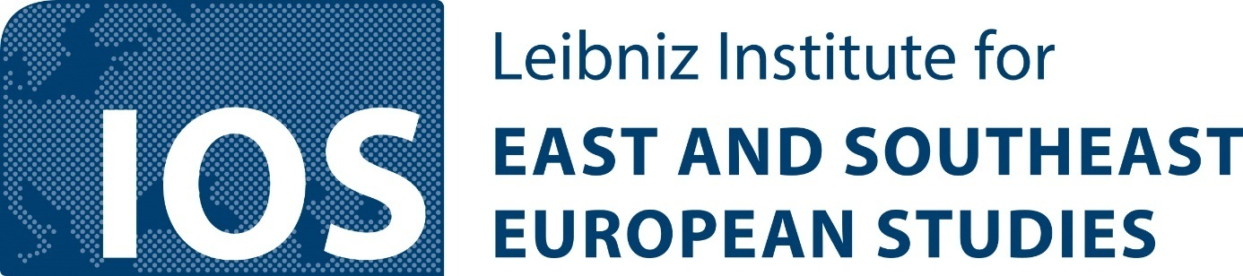
IOS-IZA Research Seminar Series of the Economics Department
Tuesday, 2 p.m. CET (unless noted otherwise)
at WiOS, Landshuter Str. 4 (Room 109) and online via Zoom. Please register at:
https://leibniz-ios.de/wissen-vermitteln/veranstaltungen/seminarreihe-des-arbeitsbereichs-oekonomie
FALL/WINTER 2023
Organizers: Hartmut Lehmann (IOS Regensburg and IZA), Olga Popova (IOS Regensburg and IZA)
October 24 (Hybrid)
Anna Nicińska (University of Warsaw)
Social barriers to sustainable transition: The case of mobility systems in Central Europe
November 7 (Zoom)
Karsten Staehr (Tallinn University of Technology and the Bank of Estonia)
Economic growth, current account dynamics and growth regimes in the Baltic states
November 14 (Hybrid)
Vladimir Kozlov (IOS)
Double bottom of grandparenting in the post-communist non-EU countries. Socially desirable burden and/or beneficial intergenerational transfers
November 21 (Hybrid)
Martin Guzi (Masaryk University and IZA)
Unstable political regimes and wars as drivers of international migration
November 28 (Zoom)
Oleksandr Talavera (University of Birmingham)
Online real estate agencies and their impact on the housing market
December 5 (Zoom)
Ori Shai (University of Haifa)
Can traumatic events affect individuals' preferences and pro-social behavior?
December 12 (Zoom)
Randolph Luca Bruno (Università Cattolica del Sacro Cuore, Piacenza)
TBA
January 9 (Zoom)
Tamás Hajdu (Institute of Economics, Centre for Economic and Regional Studies, Hungary)
Temperature exposure and sleep duration: Evidence from time use surveys
January 16 (Hybrid)
Ebru Voyvoda (Middle East Technical University – Ankara)
Evaluating the impacts of global and domestic decarbonization policies
January 23 (Zoom)
Roman Vakulchuk (Norwegian Institute of International Affairs (NUPI))
Can energy transition become a driving force for economic diversification in Central Asia?
January 30 (Zoom)
Maksym Obrizan (Kyiv School of Economics)
Violent conflict and academic research: Evidence from the 2014 conflict in Ukraine
February 6 (15.30!, Zoom)
Ion Marandici (Rutgers University-Camden)
States, oligarchs and democracy: Insights from Eastern Europe
February 20 (Hybrid, in collaboration with the Leibniz ScienceCampus Regensburg)
Slavo Radošević (School of Slavonic and East European Studies, University College London)
Techno-economic transformation in Eastern Europe and the former Soviet Union – A neo-Schumpeterian perspective
Updated October 18, 2023

